**LVM CentOS-9**

**Steps to implement LVM (Logical Volume Management) in centos-9:**

**How to create LVM:**

1. Check if additional hard disk are attacked by used fisk -l command

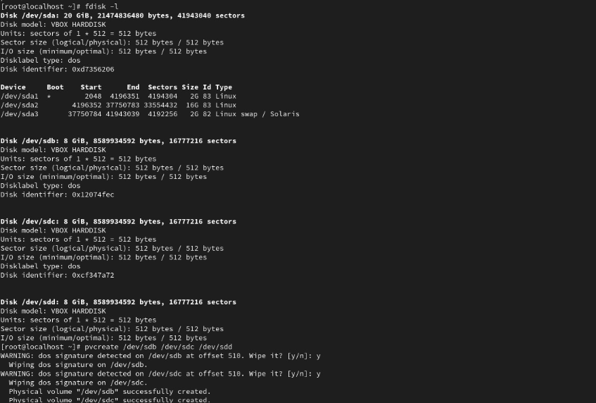

1. Creating physical Volume

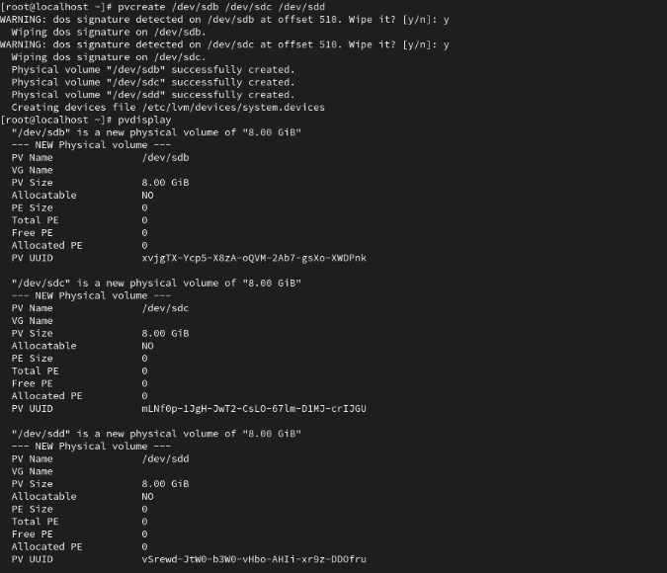

1. Creating volume Group

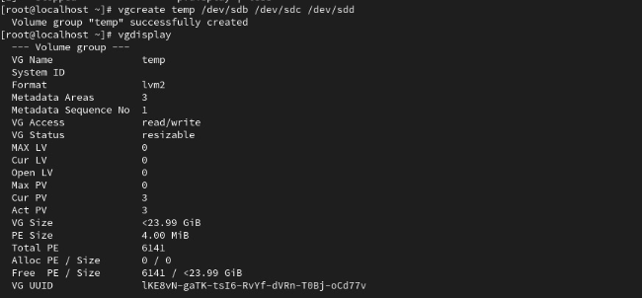

1. Creating logical volume

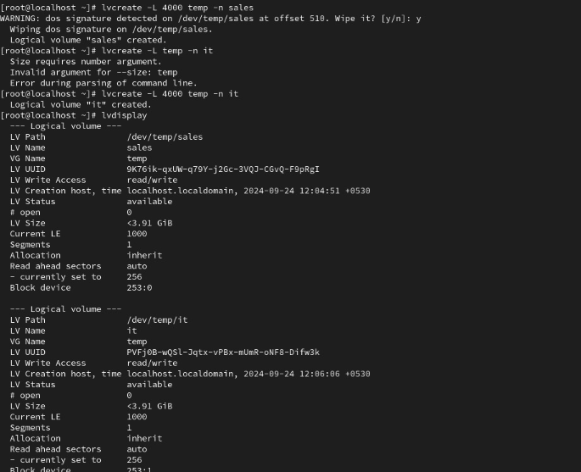

**How to use this logical volume:**

1. Make directories where you want to add logical volume



1. Format the created logical volume

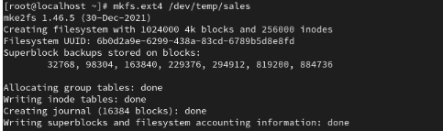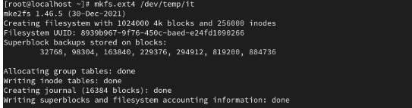

1. Mount the logical volumes to the specific locations where you want to use them in this case the directories we make step1

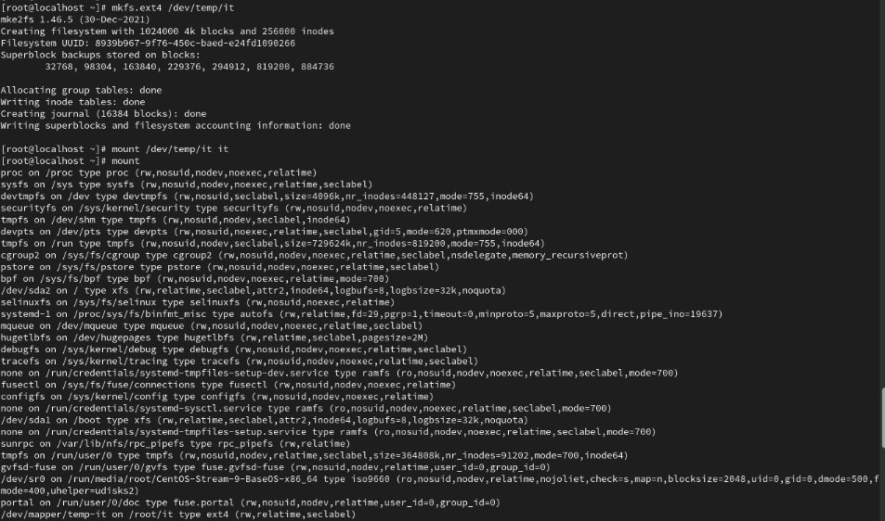

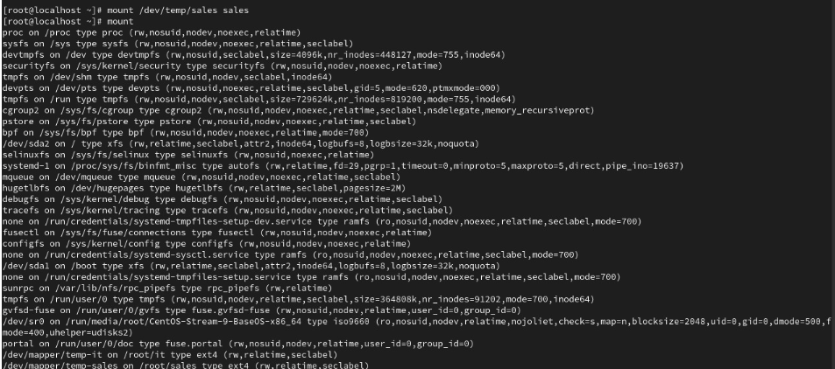

1. Use ls comand in directories to check for storage

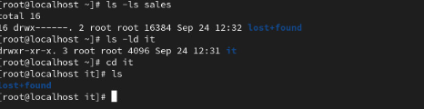

**How to remove LVM :**

1. Unmount the logical volume that you have mounted to use

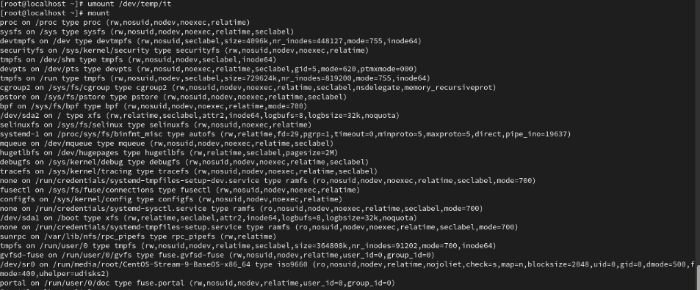

1. Remove/Delete logical volume



1. Remove/Delete volume group



1. Remove/Delete physical volume

